Announcement
of the Vice-Rector for Student Affairs of Lodz University of Technology
of 5 September 2023.

on the deadline for applying for student parking spaces on Campus A, B, C and in Zone VIII of the Students' Hall of Residence in the winter semester of the academic year 2023/2024

Pursuant to the Ordinance No. 38/2021 of the Rector of Lodz University of Technology of 21 July 2021 on the " Regulations of the Campus of Lodz University of Technology" and the Announcement of the Vice-Rector for Student Affairs of Lodz University of Technology of 17 September 2021 on defining the rules of students' application for parking spaces on the premises of Lodz University of Technology, I set the deadline for submitting applications for parking spaces on the A, B, and C Campus of Lodz University of Technology in the winter semester of the academic year 2023/2024.
§ 1
1. Applications for parking spaces on Campus A, B, C and in Zone VIII of the Student Hall of Residence in the form of an electronic form accessible via URLs or QR codes can be submitted from 12.09.2023 until 19.09.2023 at 23:59.
- Campus A and B, C, C in zone VIII of the Student Hall of Residence for TUL students
https://forms.office.com/e/a7NLdvCngn
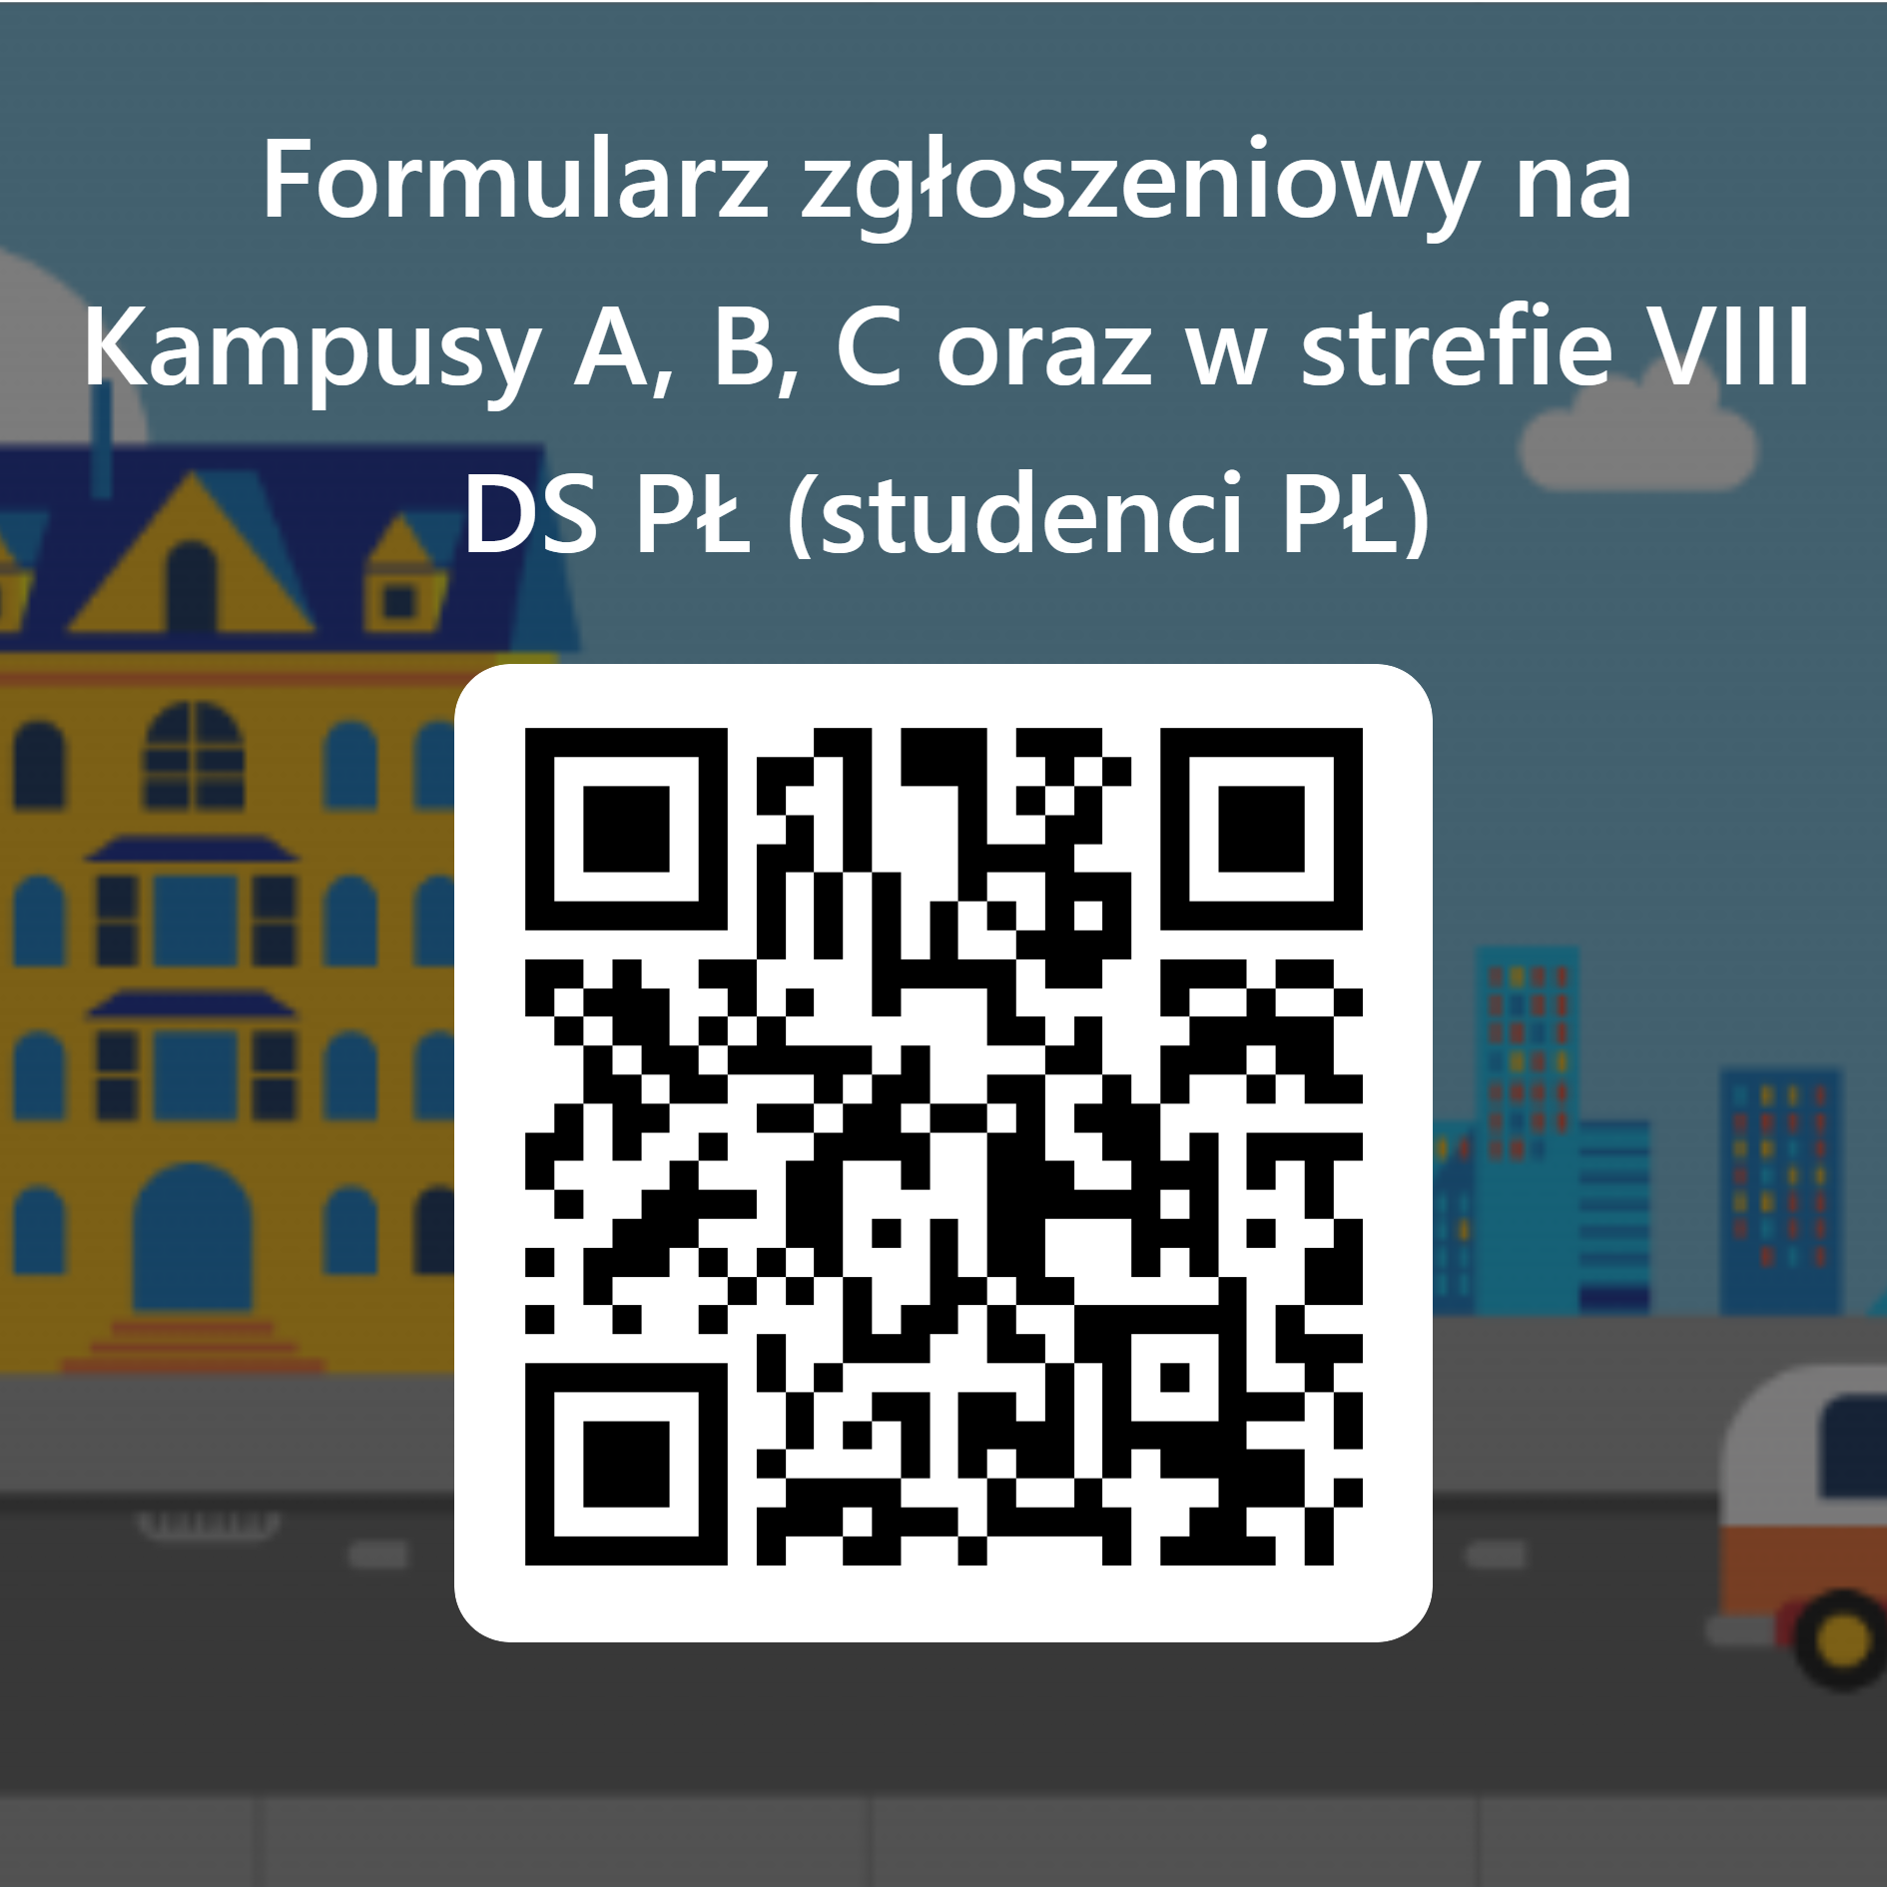

- Campus C, C in zone VIII of the Student Hall of Residence for residents of TUL Residential Area for residents who are NOT students of the Lodz University of Technology.
https://forms.office.com/e/xaG9HZ0L5g
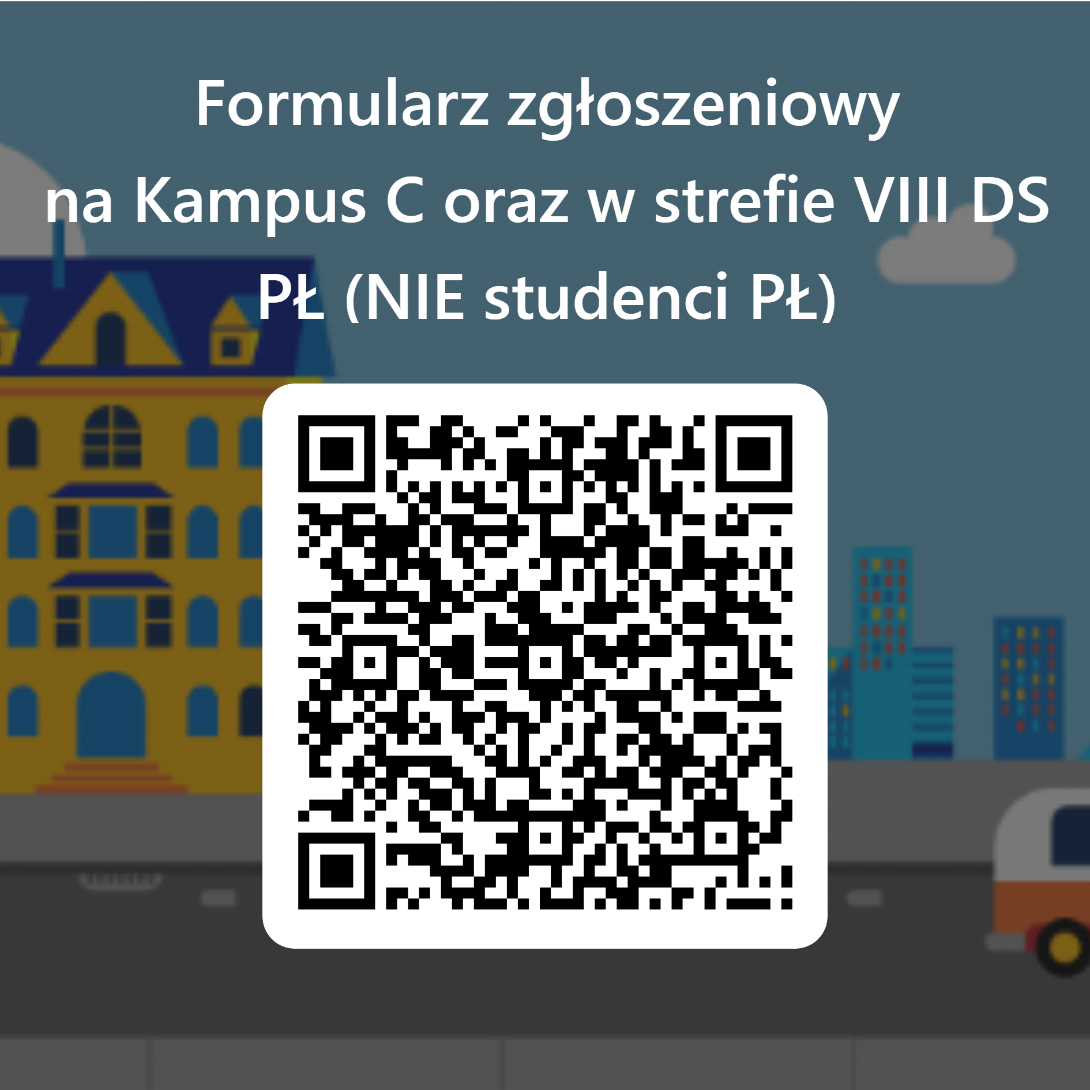
2. the preparation of the data will take place between 20.09.2023 and 24.09.2023.
3. the public draw with respect to data protection regulations will take place on the Facebook profile of the Student Government of Lodz University of Technology https://www.facebook.com/samorzadstudenckipl on 25.09.2023.
4. qualified persons will be informed about the fees via e-mail (the message may go to the spam box), and the list of persons will be forwarded to the Property Management Department by 26.09.2023.
5. Parking entitlements will be issued no later than 10.10.2023 to those who pay their parking space fee on time.
6. Information on the use of car parks in at TUL has been made available in the application form and on the TUL Student Government website
https://samorzad.p.lodz.pl/categories/parkingi/parkingi
https://samorzad.p.lodz.pl/categories/parkingi/faq-parkingi
7. questions concerning the entry card draw can be directed to: parkingi@samorzad.p.lodz.pl
§ 2
- The other permanent general rules for the granting of parking space use privileges as set out in the announcement of the Vice-Rector for Student Affairs at TUL dated 17 September 2021 shall remain in force.
- The rules set out in the Announcement shall come into force on the date of publication.

Vice-Rector for Student Affairs
Lodz University of Technology
Assoc. Prof. Witold Pawłowski, Ph.D., D.Sc.

