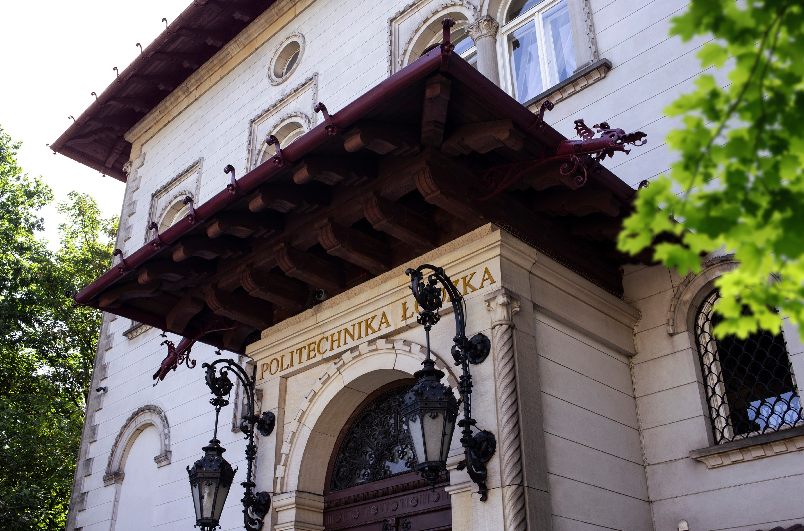
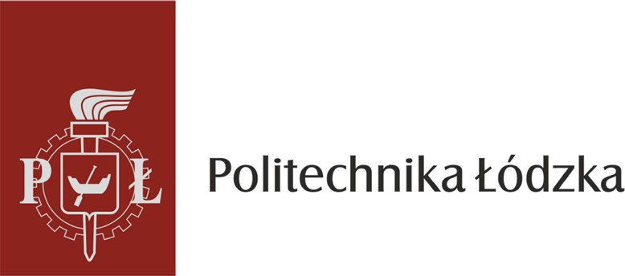

CODE OF ETHICS
FOR EMPLOYEES
OF LODZ UNIVERSITY OF TECHNOLOGY

CODE OF ETHICS FOR EMPLOYEES OF LODZ UNIVERSITY OF TECHNOLOGY

- PREAMBLE
Lodz University of Technology is a higher education institution that upholds high academic standards and requires its employees to adhere to ethical norms in their conduct and in research and teaching activities. The Code of Ethics of Employees of Lodz University of Technology is a set of guidelines for everyday conduct, based on fundamental values shaped within the national cultural tradition, which are recognized as universally binding. These include: justice, truthfulness, reliability, honesty, dignity, loyalty, freedom of belief and intellectual property rights. Their observance should take place in the spirit of the principles of social coexistence. The Code of Ethics indicates the standards of conduct that employees of Lodz University of Technology should follow while performing their official duties, both within and outside the workplace. Their fulfilment translates into building a positive image of the University, ensures the fulfilment of its development strategy, strengthens positive interpersonal relationships and affects the identification of employees with Lodz University of Technology and the effectiveness of their work. Observance of the values set out in the Code of Ethics helps build trust among employees, University authorities, and external partners. The Code of Ethics is binding for all employees of Lodz University of Technology, irrespective of their working hours or type of employment.

- EMPLOYER-EMPLOYEE RELATIONSHIP
Lodz University of Technology creates a friendly working environment and applies transparent recruitment procedures. The University observes labour law and the associated regulatory standards. Safety and dignified treatment of employees is a priority. Lodz University of Technology enables all employees to improve their competences and actively supports their professional development. It complies with working time standards and leisure needs. The University provides employees with work in accordance with the standards in the field of occupational health and safety. It raises awareness among employees of the importance of behaviours aimed at protecting health and ensuring safety during the performance of official duties.

- FUNDAMENTAL PRINCIPLES GOVERNING THE CONDUCT OF THE ACADEMIC COMMUNITY OF LODZ UNIVERSITY OF TECHNOLOGY
  - Employees of Lodz University of Technology:
    - comply with the law;
    - perform official duties with due diligence and integrity;
    - care for the good name of the University, both during the performance of employee duties and outside the workplace;
    - demonstrate a high level of personal integrity, courtesy, and respect in their dealings with all members of the academic community and with third parties;

    - adhere to the established chain of command in the conduct of employment-related affairs;
    - treat every employee of Lodz University of Technology with respect and objectivity and do not undermine the authority of other employees of the University;
    - are guided by the principle of respect for dignity and tolerance towards every person, regardless of gender, age, disability, sexual orientation and gender identity, nationality, ethnic origin, religion, religion or belief;
    - do not impose their personal views or political affiliations on third parties, while retaining the right to defend their own convictions and political sympathies, and they refrain from actions aimed at promoting any specific political party or political grouping in the course of their official duties;
    - take care of the employer's property and public funds at their disposal at the University.
  - The University strongly objects to the dissemination of untrue information and to unjustified criticism of the values enshrined in the Code of Ethics.
  - Lodz University of Technology upholds the principle of transparency in its procedures and rejects all forms of nepotism and cronyism.
  - Cooperation is a basic element of the functioning of Lodz University of Technology. The University fosters teamwork, collaborative project work, and the exchange of knowledge and experience, recognizing that effective communication and sound interpersonal relations among employees contribute to stable and high-quality working conditions.

- EXECUTION OF DUTIES BY ACADEMIC STAFF
Compliance with ethical values and high standards of scientific integrity is associated with the particular responsibility of the scientific community, regarding the general public and the natural environment. The universal ethical values on which the coherence of the scientific community and the authority of science are based should be respected by all its representatives, regardless of the type or discipline of research.

Universal ethical principles for the scientific community:
  - Academic teachers:
    - maintain a high level of research in accordance with international standards;
    - maintain independence in conducting research towards the entities commissioning it and from pressure from political, ideological, religious and economic factors;
    - report research findings accurately and transparently, adhering to thoroughness and the principles of established scientific critique;
    - maintain the up-to-date nature of the knowledge they convey and exhibit diligence and accuracy in its dissemination;
    - take care to document scientific research transparently, ensuring accessibility to the results, especially by properly documenting and securely archiving raw data, which can substantiate the authenticity of the research in case of any disputes;
    - ensure thorough, objective, and substantive review of others’ works, scientific achievements, and research concepts;
    - do not undertake to review other people's works, scientific achievements and research concepts when it goes beyond their knowledge, experience and competence;
    - do not violate someone else's copyright and related rights as well as industrial property rights, and do not falsify works and research results, and do not mislead as to the authorship of someone else's work. If an academic teacher has used someone else's research,

scientific achievements, publications or works, they are obliged to indicate the author and/or source from which the information originates.
    - they base authorship in scientific publications on creative contribution to research, creation of scientific ideas, formulation of new concepts and significant participation in research design. The scientific publication should be based on active participation in the acquisition of data, their analysis and interpretation, as well as substantive and critical elaboration from the point of view of applicable scientific criteria;
    - observe the principles of reliability in science by not including in co-authorship in scientific publications persons who have not made a sufficient contribution to their creation and not submitting supervisors to co-authors only because they were created by employees subordinate to them;
    - avoid cooperation with environments whose unambiguous status cannot be confirmed, e.g., by an appropriate affiliation, institutional e-mail address and which, in the first place, offer co-authorship in a scientific article, and not participation in a joint research project (the so-called research paper mills);
    - oppose the creation of plagiarism and strive to oppose it;
    - make active efforts to raise funds for scientific research and to properly use these funds;
    - strive to objectively and reliably assess the knowledge, skills and attitude of students, doctoral candidates and employees as well as representatives of the scientific community;
    - share resources that have been purchased with public funds in accordance with the rules in force at the University and take care of the condition of the equipment and scientific resources entrusted to them;
    - take responsibility for the proper conduct of research: research involving humans or animals may be conducted only if it is necessary and always with respect for human dignity and animal rights, on the basis of the consent expressed by the relevant ethics committees, including bioethics committees.

- DIGNIFIED CONDUCT OF ACADEMIC TEACHERS
  - Academic teachers should:
    - maintain objectivity in evaluations and presenting views, i.e. be based solely on facts and verifiable data;
    - be open in scientific discussions and willing to exchange scientific information and experiences;
    - boldly oppose views that contradict current scientific knowledge and practices that undermine scientific integrity;
    - be willing to cooperate, open to new ideas and research initiatives;
    - in the teams they lead, foster the formation and maintenance of a friendly atmosphere and fair competition in research work;
    - speak publicly in the field of research within the scope of their competence, and maintain integrity and accuracy in their statements when communicating with the media and the general public;
    - respect the copyright and do not show co-authorship of scientific publications in the editing of which they did not participate;
    - establish cooperation with editorial boards of journals and committees organising scientific conferences;
    - take into account the opinions of students and doctoral candidates on the programme, the course of study and teaching activities;

    - counteract all forms of discrimination, including harassment and mobbing among colleagues, doctoral candidates and students;
    - take care of the scientific development of young scientists and make them sensitive to ethical standards and norms;
    - behave with dignity within and outside the workplace and do not violate the legal and social order, which could affect the authority and credibility of the University.

- EXECUTION OF DUTIES BY NON-ACADEMIC PERSONNEL
Employees who are not academic teachers, like academic teachers, co-create the image of Lodz University of Technology by maintaining an ethical attitude and proper performance of official duties. Work at the University should be treated by them as a service to the academic community and the general public.

Fundamental ethical principles for non-academic personnel:
  - Employees of Lodz University of Technology are obliged to:
    - perform their duties honestly, diligently, and on time, drawing on their knowledge, professional experience, and skills to ensure the highest possible effectiveness of their work;
    - treat all co-workers and interested parties on an equal footing;
    - not succumb to unlawful pressure or threats and not to undertake to mediate in any matter at the University in connection with the existence of a relationship resulting from kinship, acquaintance or other sources;
    - oppose any attempts to grant financial or personal benefits or promises thereof;
    - inform their superior and take corrective action in the event of an error or negligence that affects or has consequences for the functioning of the unit or team;
    - observe generally accepted forms of courtesy in interpersonal contacts, as well as in paper and electronic correspondence;
    - report to their superior any cases of mismanagement, attempts to embezzle public funds, corruption or other activities that raise doubts as to their purpose or legality;
    - oppose all manifestations of pathology in academic and social life;
    - respect private property;
    - take measures to protect the environment;
    - improve their professional qualifications;
    - use their working time fully and appropriately for their official duties;
    - take care of their workplace;
    - observe confidentiality as specified in separate regulations;
    - look after the employer's interests, protect their property and keep confidential any information whose disclosure could expose the employer to harm;
    - know and comply with the legal acts in force at the University necessary for the performance of their duties;
    - respond to behaviour that violates the Code of Ethics.

- DIGNIFIED CONDUCT OF EMPLOYEES WHO ARE NOT ACADEMIC TEACHERS
  - Employees of Lodz University of Technology should:
    - take an interest in the University matters;
    - have a high level of personal culture and take care of their image;
    - behave with dignity both at work and outside of work and not violate legal and social order, which could undermine the authority and credibility of the University.
    - be loyal and honest towards their superiors, subordinates, colleagues and clients. Workplace relationships should be based on cooperation, camaraderie, mutual respect, assistance, and sharing knowledge and experience.
    - avoid shirking difficult decisions arising from the performance of their official duties and the resulting responsibilities.
    - counteract all forms of discrimination, including harassment and bullying of colleagues.

- FINAL PROVISIONS
  - In matters not covered by the Code of Ethics, the provisions of the Act of 20 July 2018 shall apply – Law on Higher Education and Science (i.e. Journal of Laws of 2023, item 742, as amended), the Act of 26 June 1974 Labour Code (i.e. Journal of Laws of 2023, item 1465, as amended), the Statute of Lodz University of Technology and the Work Regulations at Lodz University of Technology.
  - Every employee taking up employment at Lodz University of Technology shall familiarise themselves with the content of the Code of Ethics before commencing work and shall be obliged to comply with it, which they shall confirm by submitting a statement, a template of which is attached as Appendix 1 to this Code. The signed declaration is included in the employee’s personal records by the TUL Human Capital Management Centre.
  - Violation of the provisions of the Code of Ethics by a University employee may result in liability under the provisions of the Work Regulations at Lodz University of Technology.

Appendix No. 1
to the Code of Ethics for Employees of Lodz University of Technology
dated... 2023

……………………………………………...…………. (name and surname)

…………………………………………….…………………. (organisation unit)

Statement of Familiarization
with the Code of Ethics of Employees of Lodz University of Technology

I declare that I have read the Code of Ethics for Employees of Lodz University of Technology and undertake to comply with its provisions.

……………………………………date and employee signature

CODE OF ETHICS
FOR EMPLOYEES
OF LODZ UNIVERSITY OF TECHNOLOGY

